JDBC RowSet

The instance of **RowSet** is the java bean component because it has properties and java bean notification mechanism. It is introduced since JDK 5.

It is the wrapper of ResultSet. It holds tabular data like ResultSet but it is easy and flexible to use.

The implementation classes of RowSet interface are as follows:

* JdbcRowSet
* CachedRowSet
* WebRowSet
* JoinRowSet
* FilteredRowSet

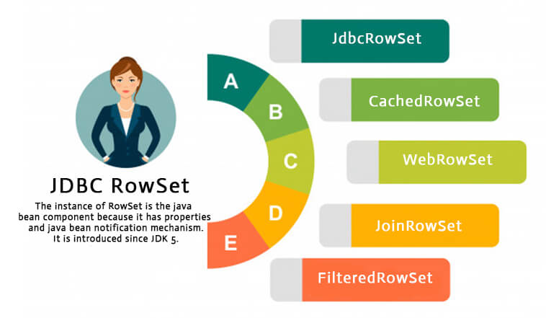

Let's see how to create and execute RowSet.

1. JdbcRowSet rowSet = RowSetProvider.newFactory().createJdbcRowSet();
2. rowSet.setUrl("jdbc:oracle:thin:@localhost:1521:xe");
3. rowSet.setUsername("system");
4. rowSet.setPassword("oracle");
6. rowSet.setCommand("select * from emp400");
7. rowSet.execute();

It is the new way to get the instance of JdbcRowSet since JDK 7.

Advantage of RowSet

The advantages of using RowSet are given below:

1. It is easy and flexible to use
2. It is Scrollable and Updatable bydefault

Simple example of JdbcRowSet

Let's see the simple example of JdbcRowSet without event handling code.

1. **import** java.sql.Connection;
2. **import** java.sql.DriverManager;
3. **import** java.sql.ResultSet;
4. **import** java.sql.Statement;
5. **import** javax.sql.RowSetEvent;
6. **import** javax.sql.RowSetListener;
7. **import** javax.sql.rowset.JdbcRowSet;
8. **import** javax.sql.rowset.RowSetProvider;
10. **public** **class** RowSetExample {
11. **public** **static** **void** main(String[] args) **throws** Exception {
12. Class.forName("oracle.jdbc.driver.OracleDriver");
14. //Creating and Executing RowSet
15. JdbcRowSet rowSet = RowSetProvider.newFactory().createJdbcRowSet();
16. rowSet.setUrl("jdbc:oracle:thin:@localhost:1521:xe");
17. rowSet.setUsername("system");
18. rowSet.setPassword("oracle");
20. rowSet.setCommand("select * from emp400");
21. rowSet.execute();
23. **while** (rowSet.next()) {
24. // Generating cursor Moved event
25. System.out.println("Id: " + rowSet.getString(1));
26. System.out.println("Name: " + rowSet.getString(2));
27. System.out.println("Salary: " + rowSet.getString(3));
28. }
30. }
31. }

The output is given below:

Id: 55

Name: Om Bhim

Salary: 70000

Id: 190

Name: abhi

Salary: 40000

Id: 191

Name: umesh

Salary: 50000

Full example of Jdbc RowSet with event handling

To perform event handling with JdbcRowSet, you need to add the instance of **RowSetListener** in the addRowSetListener method of JdbcRowSet.

The RowSetListener interface provides 3 method that must be implemented. They are as follows:

1) public void cursorMoved(RowSetEvent event);

2) public void rowChanged(RowSetEvent event);

3) public void rowSetChanged(RowSetEvent event);

Let's write the code to retrieve the data and perform some additional tasks while cursor is moved, cursor is changed or rowset is changed. The event handling operation can't be performed using ResultSet so it is preferred now.

1. **import** java.sql.Connection;
2. **import** java.sql.DriverManager;
3. **import** java.sql.ResultSet;
4. **import** java.sql.Statement;
5. **import** javax.sql.RowSetEvent;
6. **import** javax.sql.RowSetListener;
7. **import** javax.sql.rowset.JdbcRowSet;
8. **import** javax.sql.rowset.RowSetProvider;
10. **public** **class** RowSetExample {
11. **public** **static** **void** main(String[] args) **throws** Exception {
12. Class.forName("oracle.jdbc.driver.OracleDriver");
14. //Creating and Executing RowSet
15. JdbcRowSet rowSet = RowSetProvider.newFactory().createJdbcRowSet();
16. rowSet.setUrl("jdbc:oracle:thin:@localhost:1521:xe");
17. rowSet.setUsername("system");
18. rowSet.setPassword("oracle");
20. rowSet.setCommand("select * from emp400");
21. rowSet.execute();
23. //Adding Listener and moving RowSet
24. rowSet.addRowSetListener(**new** MyListener());
26. **while** (rowSet.next()) {
27. // Generating cursor Moved event
28. System.out.println("Id: " + rowSet.getString(1));
29. System.out.println("Name: " + rowSet.getString(2));
30. System.out.println("Salary: " + rowSet.getString(3));
31. }
33. }
34. }
36. **class** MyListener **implements** RowSetListener {
37. **public** **void** cursorMoved(RowSetEvent event) {
38. System.out.println("Cursor Moved...");
39. }
40. **public** **void** rowChanged(RowSetEvent event) {
41. System.out.println("Cursor Changed...");
42. }
43. **public** **void** rowSetChanged(RowSetEvent event) {
44. System.out.println("RowSet changed...");
45. }
46. }

The output is as follows:

Cursor Moved...

Id: 55

Name: Om Bhim

Salary: 70000

Cursor Moved...

Id: 190

Name: abhi

Salary: 40000

Cursor Moved...

Id: 191

Name: umesh

Salary: 50000

Cursor Moved...